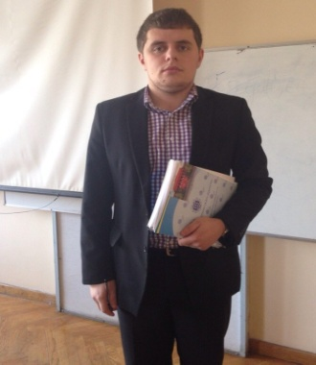**Name** Volodymyr Atamanov

Mob.tel- 07479093162

E-Mail atamanov777@gmail.com

Date of birth 03.07.1992 in Krasyliv, Khmelnytsky region, Ukraine

Status single

**Education**

1998-2009 School №2 in Krasyliv

**Study**

2009-2013 Bachelor of International Business

Institute of international relation, Kyiv Taras Shevchenko University

2013-2014 Specialist of International Business

Specialization-International Management

Institute of international relation, Kyiv Taras Shevchenko University

**Job**

Jul2008 –Sep2008 Agroparter LLC

Summer intership

Jul2011-Sep2011 McDonald’s Corporation

summer internship

Jun2012-Aug2012 **Hotel«Dunennhaus Vitte»(German)**

summer internship

**Foreign languages**

English, German fluent

**Computer skills** MS Office, Internet and social media skills

**Retraining (mobility visits)**

2009-2014 «Democracy, active citizenship and youth participation»([Sharm el-Sheikh](http://en.wikipedia.org/wiki/Sharm_el-Sheikh), Egypt**),** EU international program (Hungary), EU «Youth in Aсtion» Programme (Baku).

# UN Secretary-General Ban Ki-moon lecture, Union), senior economist at RBS Markets, the investment-banking division of Royal Bank of Scotland Rous Vouker, Director of "Porsche Ukraine" Thomas Rushytska(«The art of professional presentation and negotiation in the business»).

**Activities**

2009-2014 [Head of the group](http://www.linkedin.com/search?search=&keywords=head+of+the+group+%28+4+years%29%2E+Founder+of+University+Debate+Club+%28+35+active+members&sortCriteria=R&keepFacets=true&trk=prof-edu-activities_and_societies), Ambassador Club member, member of University Debate Club, football team captain.