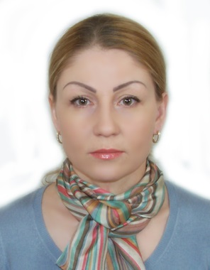 Nailya kurbangaliyeva

Cell: +971551584190
Marital status: Single
E-mail: naily_taraz777@mail.ru
______________________________________________________________

Objective: To obtain a position related to my field of study & experience in a dynamic company with growth potential where I can utilize my skills and background.

Highlights of qualifications:

- Valuable knowledge of accounting support
- Patient’s medical courses follow-ups.
- Organizing the patient’s schedule to avoid any conflict.
- Valuable knowledge of how to overcome the possible problems as a scheduler to support patient’s and doctor’s right.
- Working as a interpreter between the patients and doctors (English-Russian)
- Hard working, punctual, active and reliable.
- Well established to work independently as well as a member of a group.

Education:

- Graduated in obstetrician (Medical bachelor) from Zhambyl medical college.(zhambyl Kazakhstan)
(Bachelor degree)
- General secondary school from Zhambyl, Kazakhstan
- English and computer courses from polyglot institute (Dubai. UAE)

Professional Experiences:

Doctor jack dental clinic April 2006- present Dubai

♦ accounting support

- Patient’s medical courses follow-ups.
- Organizing the patient’s schedule to avoid any conflict

Laboratory technician of bacteriological Laboratory Feb 1996- march 2006 Kazakhstan

♦ Diseases analyzer.
♦ Result report organizer
♦ Patients follow-ups

Academic and computer skills:
- All Microsoft operating systems (ME, XP & Vista)
- Microsoft Office (Word, Excel & PowerPoint).

Languages
- Kazakh – Native Language
- Russian – Second Native Language
- English – Speak Fluently Read/Write

References: Available upon request.

