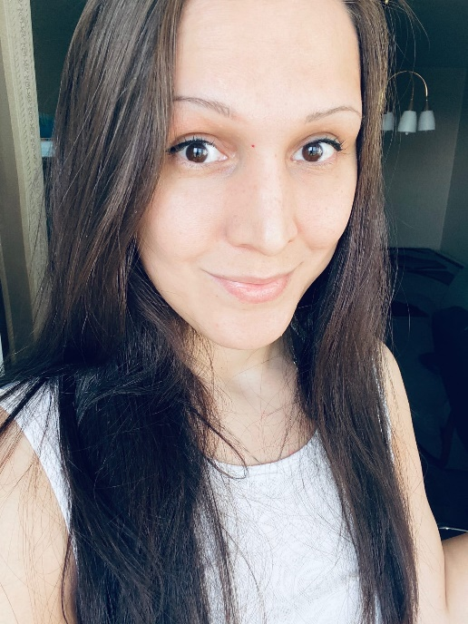  Diana shugaeva  English teacher  Female  married  contact info  e-mail: poloskamail@gmail.com |  | Hello!~  My name is Diana, I’m high qualified English teacher. I have 7 years teaching experience in secondary school. I want to apply to your vacancy because I love kids and I can do my best to take care of them properly. I think my teaching experience would be a great support for this position.  Here is some information of my present and past working experience and personal skills.  Education level: Higher. Bachelor  Name of the university: Saint Petersburg State Polytechnic university, Institute of humanities  A year of graduation: 2022  (I also have my second diploma in management)  Working Experience (last 3):  - 2018- present days: Secondary school No.313 in St.Petersburg, Russia.  Teacher of English  - 2016-2017: Teen Club  Tutor  - 2015-2016: Educational and Methodological Center  Methodologist  Professional Knowledge and skills: Accuracy, positive attitude, desire to work, fast learning ,flexability.  Personal skills: responsibility, attention to detail, love children.  Mother tongue: Russian.  Citizenship: Russia  English language level: C2.

